Chapter 9  
Modeling for image classification and segmentation

Computer vision tasks are among the most popular problems

Main types of image-related challenges: classification, segmentation

# Augmentation strategies

While deep learning techniques have been extremely successful in computer vision tasks like image recognition, segmentation or object detection, the underlying algorithms are typically extremely data intensive: they require large amounts of data to avoid overfitting. However, not all domains of interest satisfy that requirement – which is where data augmentations come in. It is a name for a group of image processing techniques that create modified versions of images, thus enhancing the size and qualify of training datasets, leading to better performance of deep learning models. The augmented data will typically represent a more comprehensive set of possible data points, thus minimizing the distance between the training and validation set, as well as any future testing sets.

In this section we will review some of the more common augmentation techniques, along with choices for their software implementations. The most frequently used transformations include:

* Flipping: flipping the image (along the horizontal or vertical axis)
* Rotation: rotating the image by a given angle (clockwise or anticlockwise)
* Cropping: a random subsection of the image is selected
* Brightness: modify the brightness of the image
* Scaling: image is increased to higher (outward) or lower (inward) size.

On a high level, we can say that augmentations can be applied in one of two manners:

* **Offline**: those are usually applied for smaller datasets (fewer images or smaller sizes – although the definition of ‘small’ depends obviously on the available hardware). The idea is to generate modified versions of the original images as a preprocessing step for your dataset, and then use those alongside the ‘original’ ones
* **Online**: used for bigger datasets – the augmented images are not saved on disc, the augmentations are applied in mini batches and then fed to the model

In the next few sections, we will overview two most common methods for augmenting your image dataset: the built-in Keras functionality and the albumentations package. There are several other options available out there (skimage, OpenCV, imgaug, Augmentor, SOLT), but we focus on the most popular ones.

The methods discussed in this chapter focus on image analysis powered by GPU – using the Tensor Processing Units (TPU) is an emerging, but still somewhat niche application. Readers interested in image augmentation in combination with TPU-powered analysis are encouraged to check the excellent work of Chris Deotte @cdeotte:

<https://www.kaggle.com/cdeotte/triple-stratified-kfold-with-tfrecords>

We will be using data from the Cassava Leaf Disease Classification competition <https://www.kaggle.com/c/cassava-leaf-disease-classification>. As usual, we begin with the groundwork: first, loading the necessary packages

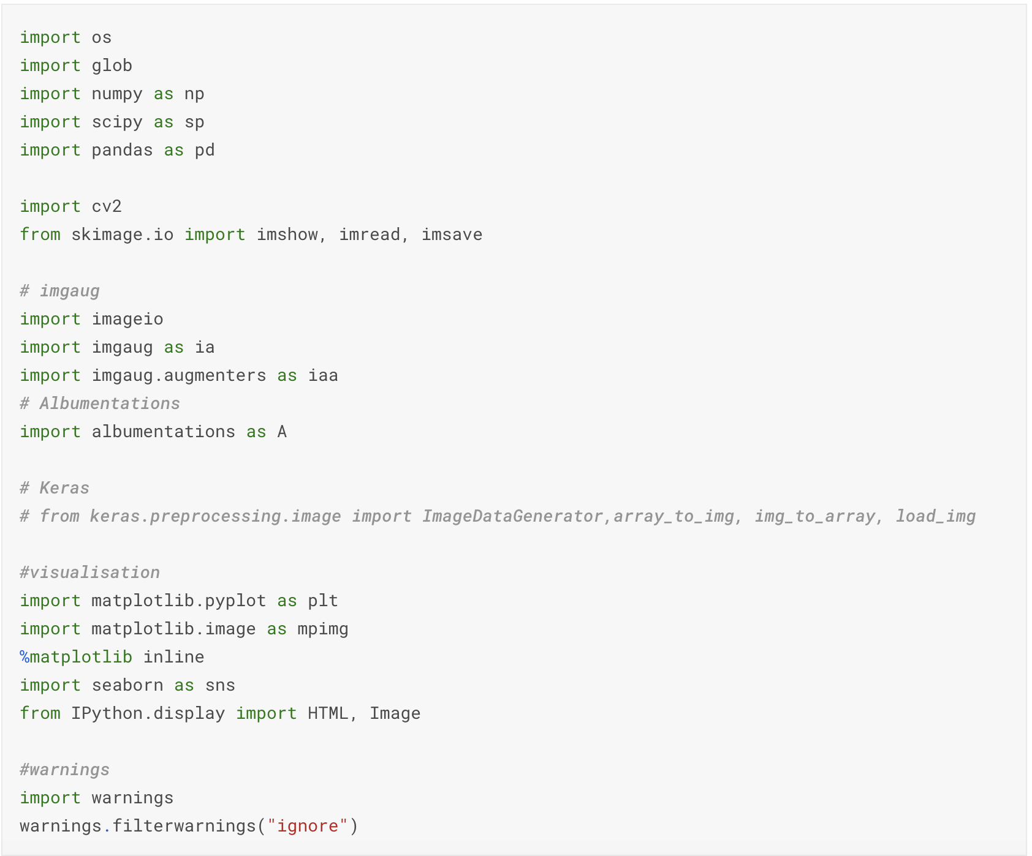

Next, we define some helper functions that will streamline the presentation later

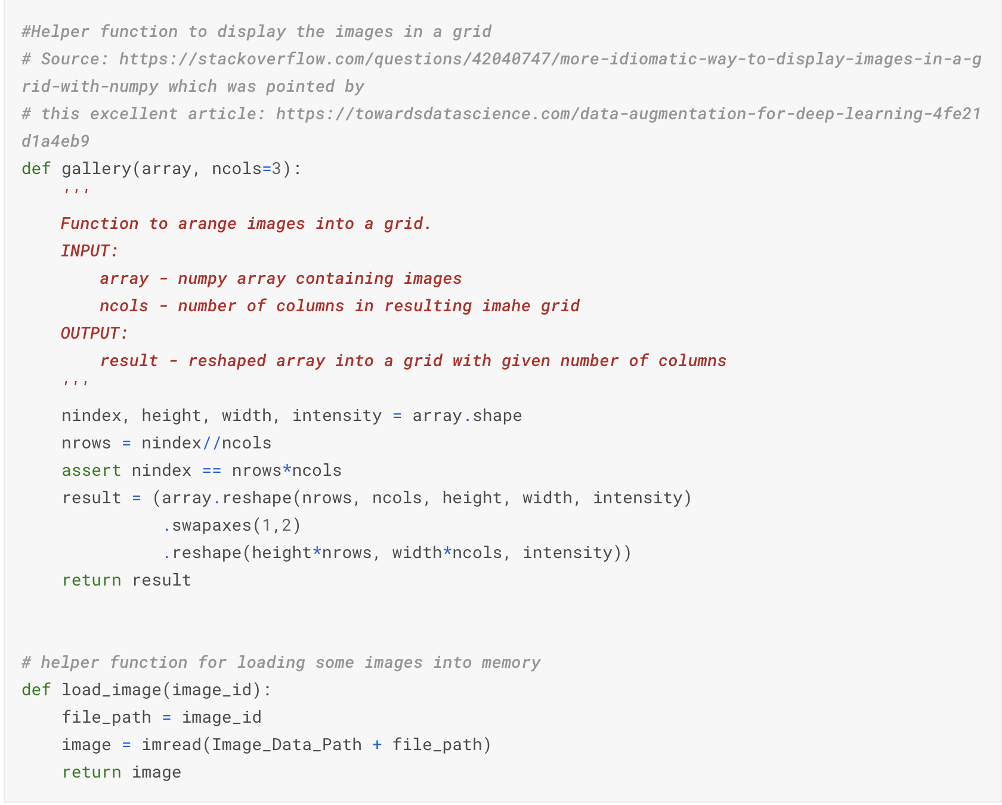

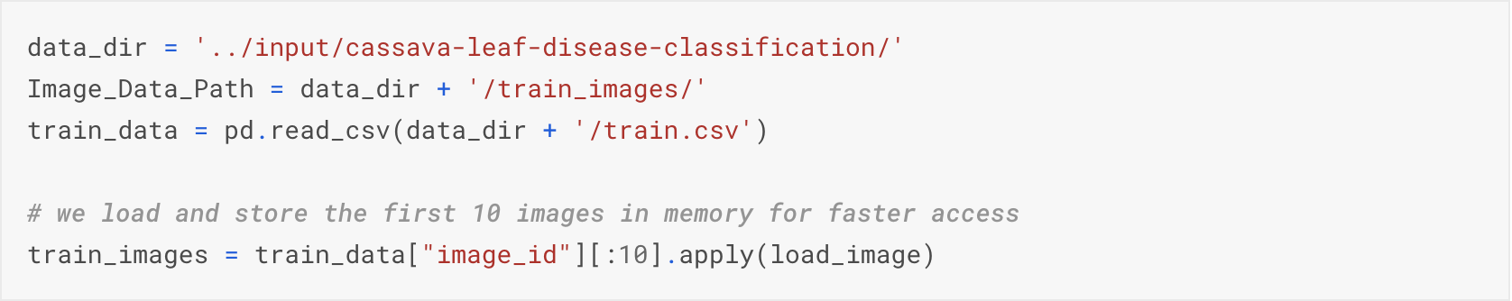

Let’s load a single image to know what our reference is:

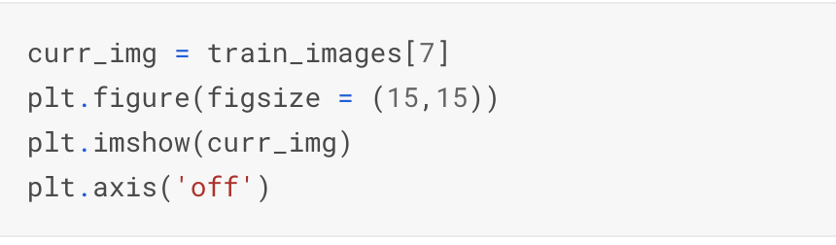

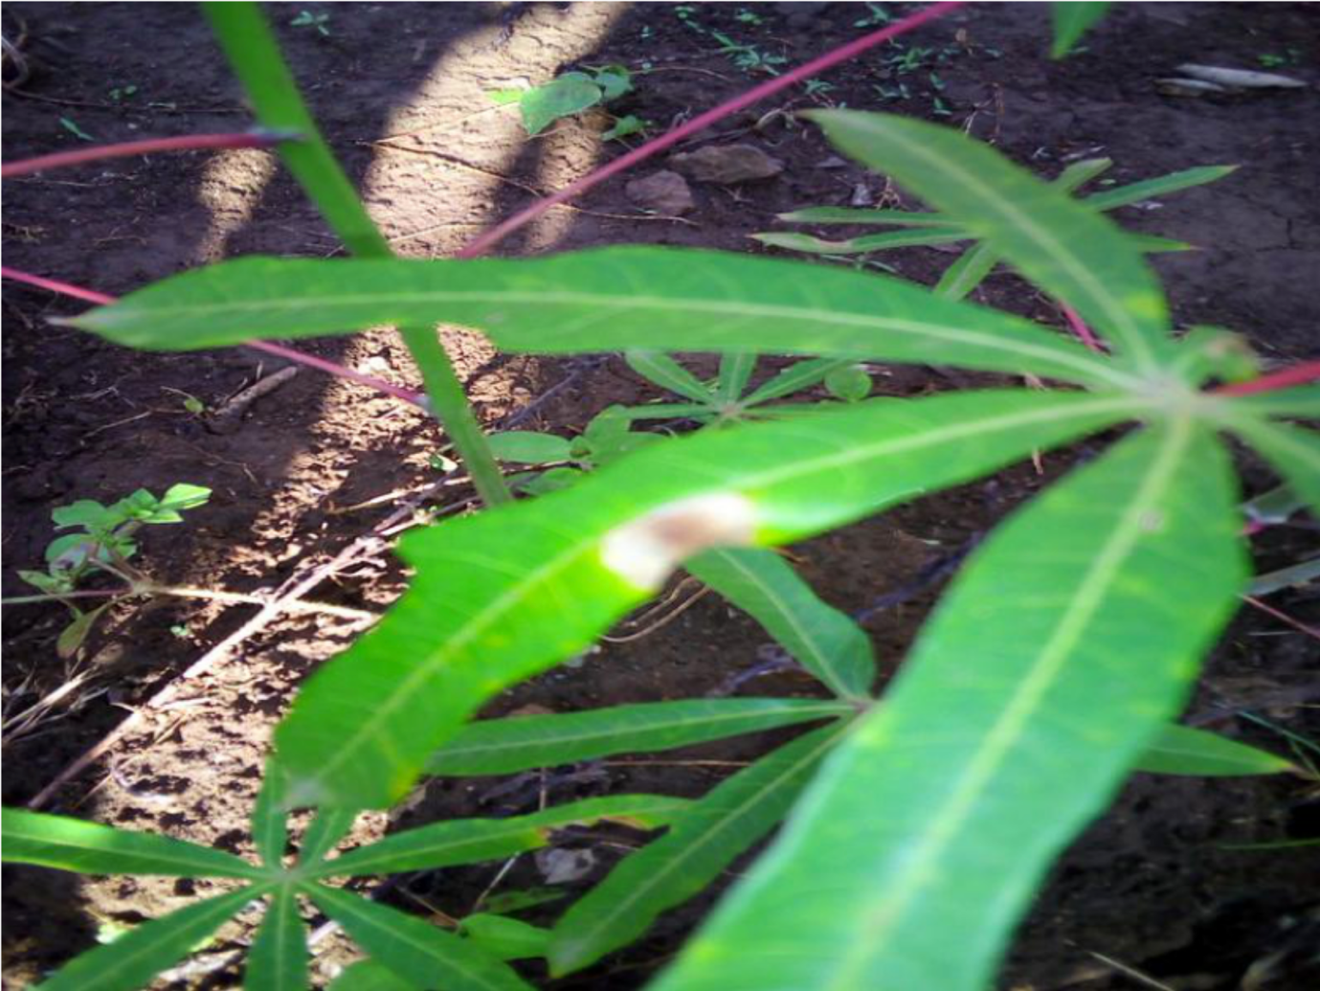

## Keras built-in

Keras library has a built-in functionality for augmentations. While not as extensive as dedicated packages (albumentations, or others mentioned earlier), it has an advantage of easy integration with your code. The first approach is based upon the ImageDataGenerator class: as the name suggests, it can be used to generate batches of image data with real-time data augmentations.

### ImageDataGenerator approach

We begin by instantiating an object of class ImageDataGenerator in the following manner:

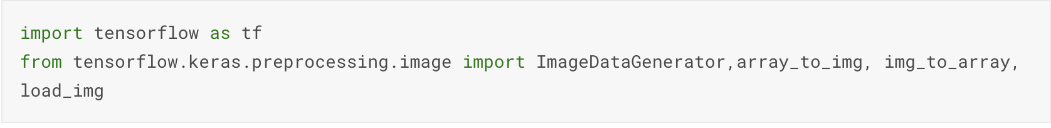

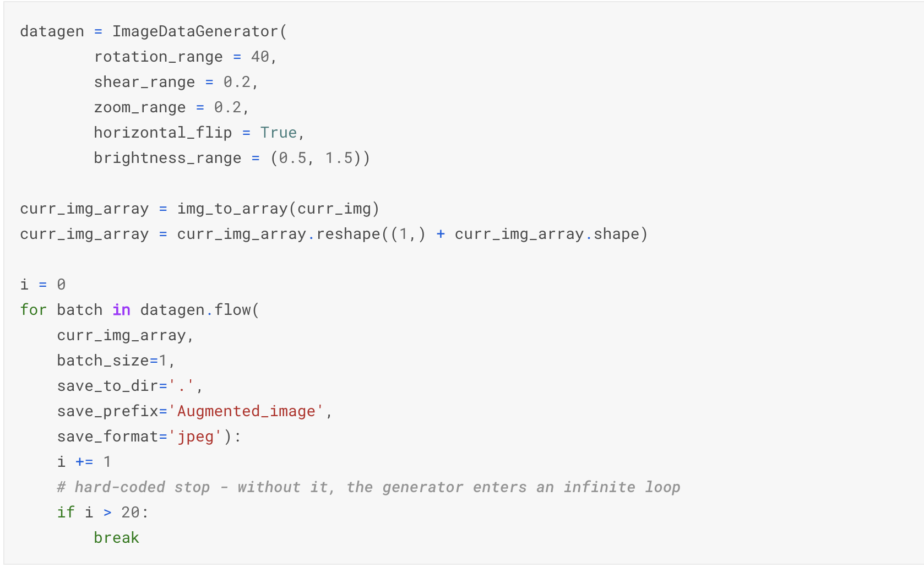

We define the desired augmentations as arguments to ImageDataGenerator – in the above example we utilize only a limited subset of possible options, for full list the reader is encouraged to consult the official documentation: <https://keras.io/api/preprocessing/image/>

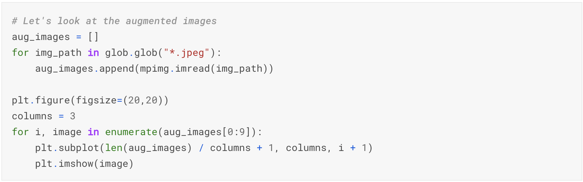

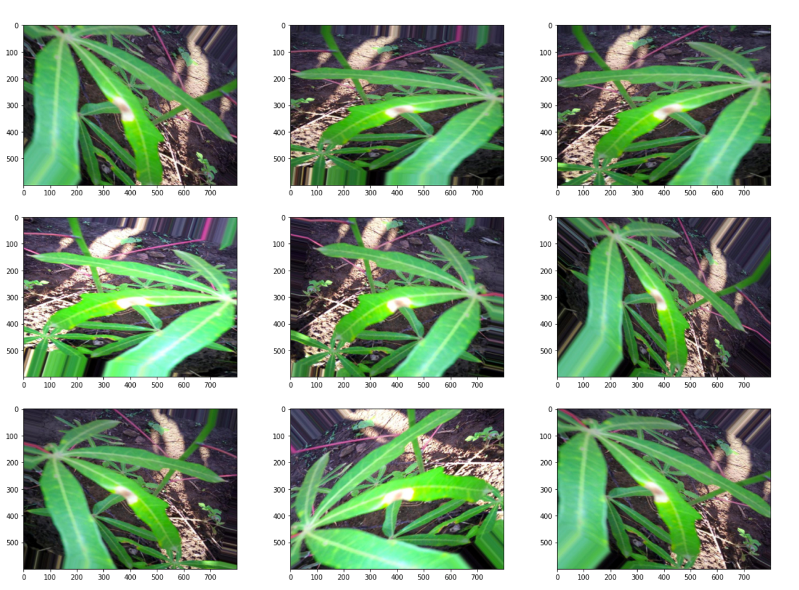

### Preprocessing layers

An alternative approach to data augmentation as a preprocessing step in a native Keras manner is to use the preprocessing layers API. The functionality is remarkably flexible: such pipelines can be used either directly in combination with Keras models or independently in a manner similar to the ImageDataGenerator. Below we show briefly how a preprocessing layer can be setup – we will return to this when we demonstrate a complete modeling pipeline in the next section.

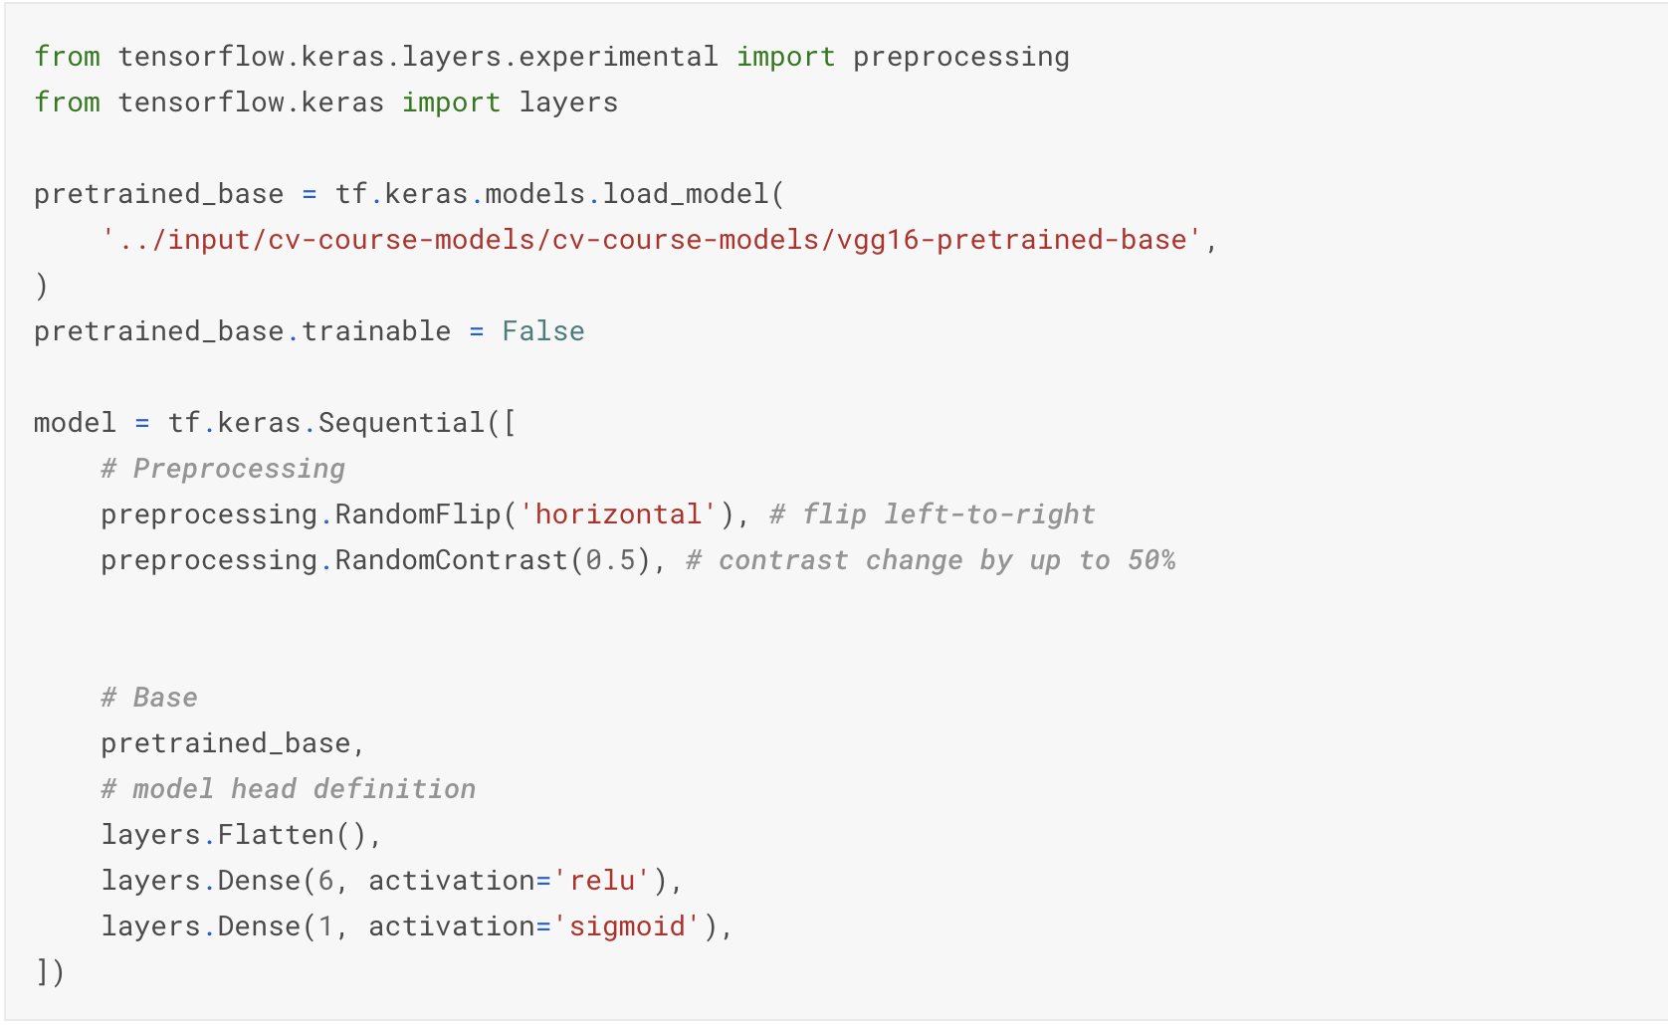

## Albumentations

The albumentations package is a fast image augmentation library which is built as a wrapper of sorts around other libraries (the design philosophy was to combine the most useful bits from numpy, OpenCV and imgaug). The full documentation can be found at: <https://albumentations.readthedocs.io/en/latest/>

Using albumentations functionality to transform an image is straightforward:

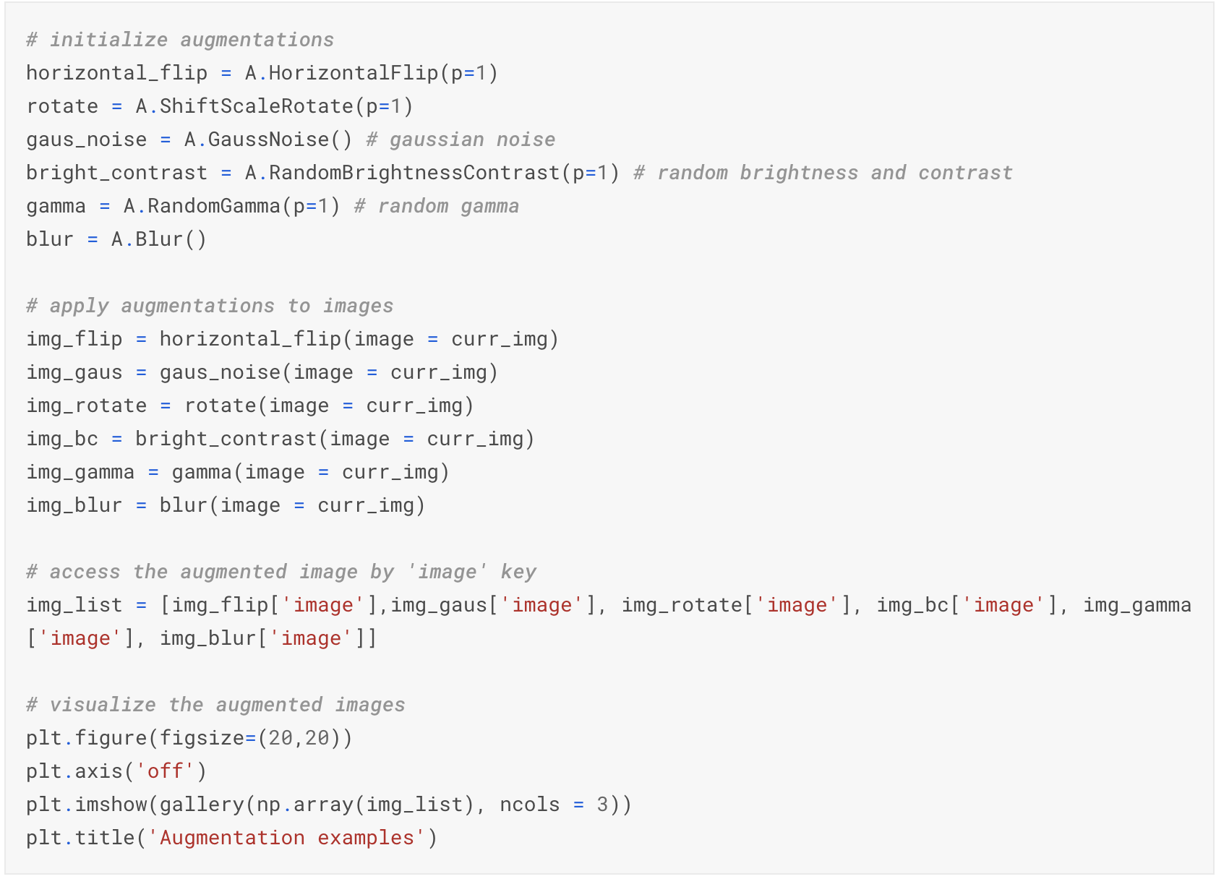

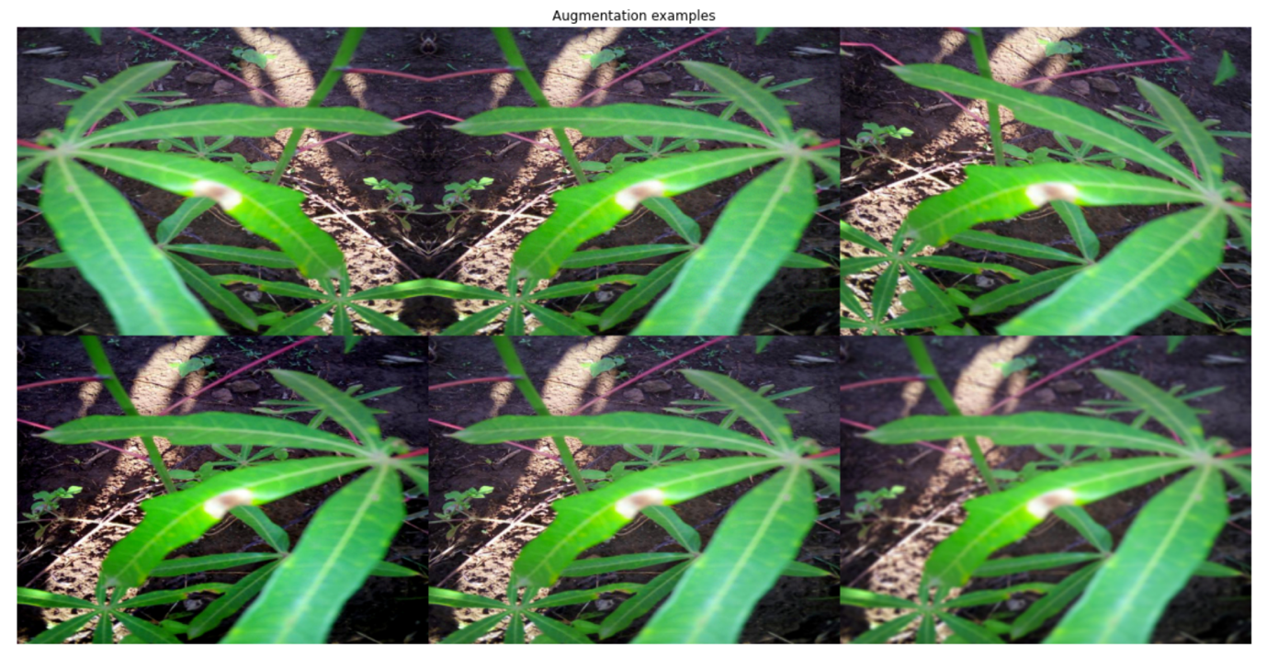

Having discussed a crucial preprocessing step in approaching a computer vision problem, we are now in a position to apply this knowledge. This is the topic addressed in the next section on image classification.

# Classification

In this chapter we demonstrate an end-to-end pipeline that can be used as a kind of template for handling image classification problems. We walk through all the necessary steps – from data preparation, through model setup and estimation, to results visualization; apart from being informative (and cool), this last step can also be very useful if you need to examine your code in-depth to get a better understanding of the performance.

As usual, we begin with loading the necessary libraries.

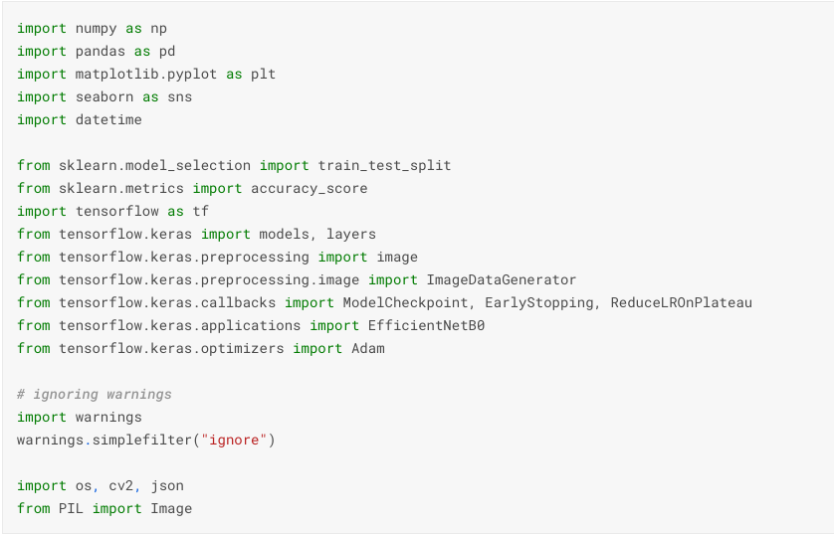

It is usually a good idea to define a few helper functions – it makes for a code that is easier to both read and debug. If you are approaching a general image classification problem, a good idea to start with are models from the EfficientNet category, introduced in a 2019 in paper from the Google Research Brain Team: <https://arxiv.org/abs/1905.11946>. The basic idea is to balance network depth, width and resolution to enable more efficient scaling across all dimensions and subsequently better performance. We use the simple B0 model, add a pooling layer on top, followed by a dense activation one.

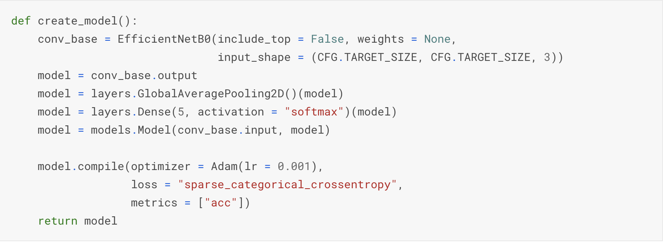

The helper function below allows us to visualize the activation layer, so we can examine the network performance from a visual angle – this is frequently helpful in developing an intuition in a field notorious for its opacity.

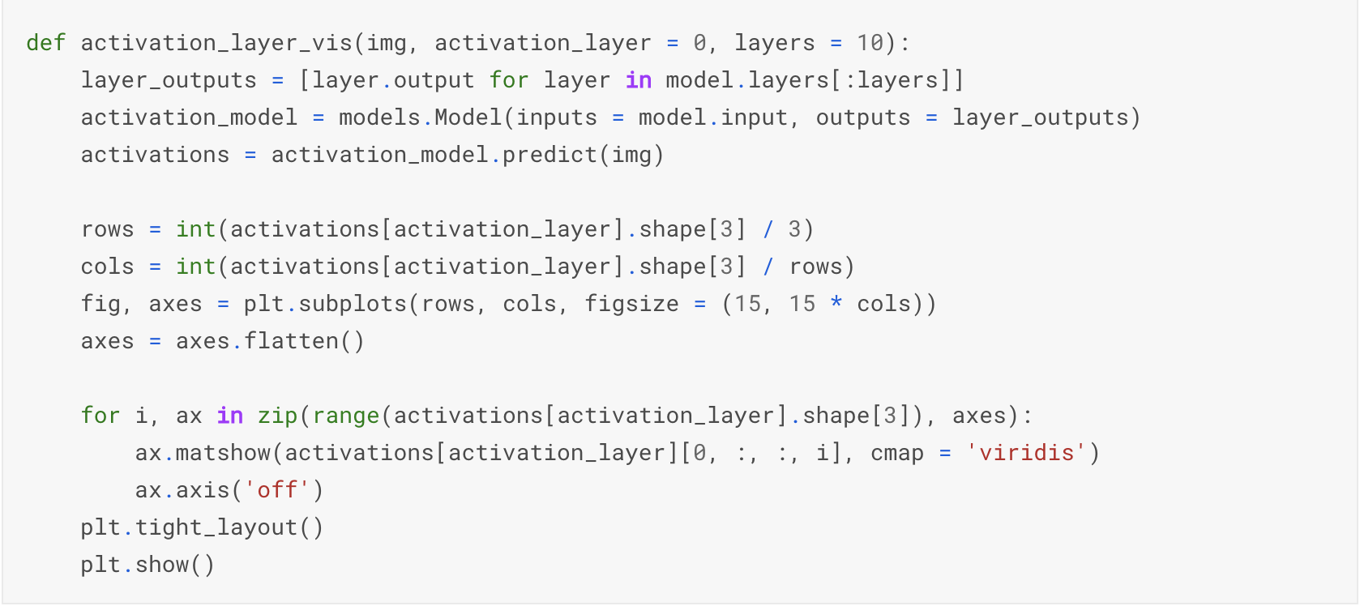

Next, we process the labels and setup the validation scheme:

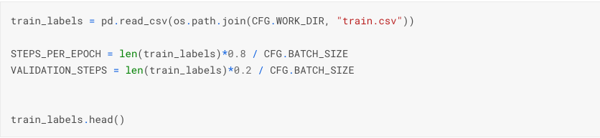

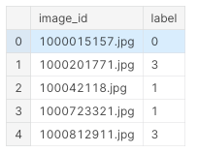

We are now able to setup the data generators – necessary for our TF-based algorithm to loop through the image data. First, we instantiate two ImageDataGenerator objects (discussed in the previous section) – this is the moment when we incorporate the image augmentations; for the purpose of this demonstration, we go with the ones built-in. After that, we create the generator using a flow_from_dataframe method, which is used to generate batches of tensor image data with real-time data augmentation.

Once our model is created, we can quickly examine a summary – this is mostly useful for sanity checks, because unless you have a photographic memory, chances are you are not going to remember the layer composition batches of a sophisticated model like EfnetB0.

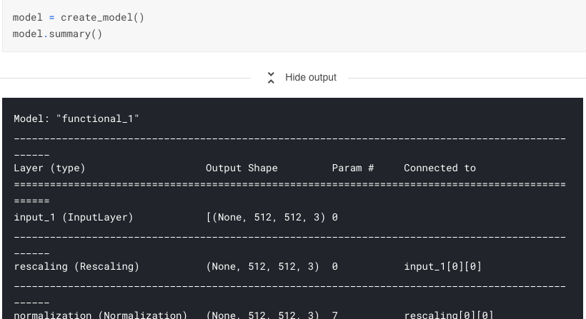

With the above steps taken care of, we can proceed to fitting the model:

* Typically, we might want to re-use the fitted model, so it is useful to preserve the best weights; this is what ModelCheckpoint is used for
* One of the popular methods for preventing overfitting is early stopping: we monitor the performance of the model on the holdout set and stop the algorithm if the metric stops improving for a given number of epochs
* Models often benefit from reducing the learning rate once learning stagnates – the ReduceLROnPlateau callback monitors the loss on the holdout set and if no improvement is seen for a 'patience' number of epochs, the learning rate is reduced.

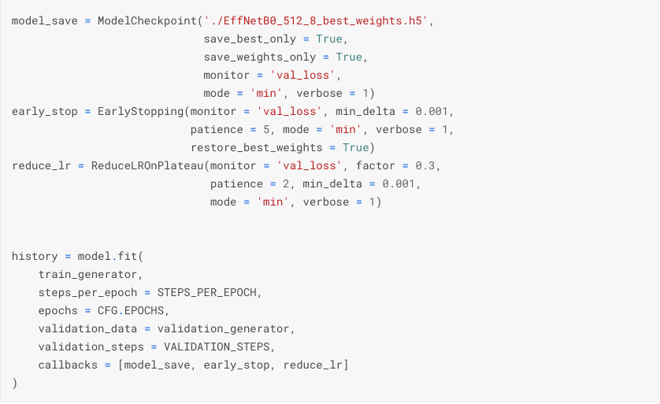

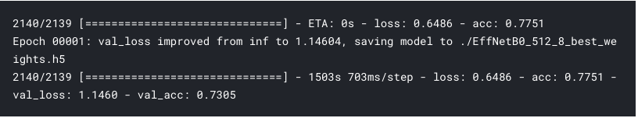

Once a model is fitted, we can examine the activations on a sample image:

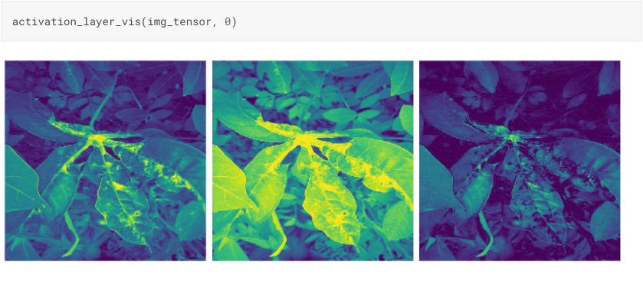

# And generate the prediction:

# In this section we demonstrate a minimal end-to-end pipeline for image classification. Numerous improvements are of course possible (more augmentations, bigger architecture, callbacks customization), but the basic underlying template should provide the reader with a good starting point going forward.

# We move now to a second popular problem in computer vision: segmentation.

# Semantic segmentation

The easiest way to think about segmentation is that classifies each pixel in an image, thus assigning it to a corresponding class; combined, those pixels form areas of interest like marking regions with disease on an organ in medical images. By contrast, object detection classifies patches of an image into different object classes and creates bounding boxes around them. We will demonstrate the modeling approach using data from the Severstal Steel Defect Detection competition <https://www.kaggle.com/c/severstal-steel-defect-detection>. The task in this contest was to localize and classify surface defects on a steel sheet.

The code in this demonstration is adapted from an excellent notebook by Chris Deotte <https://www.kaggle.com/cdeotte>: a quadruple Kaggle Grandmaster, fantastic educator through the notebooks he creates and discussions he participates in – overall, a person definitely worth following for any Kaggler, irrespective of their level of experience.

We begin by installing the extra package for segmentation – as of the time of this writing, segmentation-models <https://segmentation-models.readthedocs.io/en/latest/index.html>

Is not part of the Kaggle Docker image. We can either install such dependencies directly (as we do here), or – if the competition rules forbid the usage of internet – upload it as a dataset (as discussed in chapter 5) and then install it from a local copy.



We proceed in the usual manner by loading the necessary packages – since the segmentation-models package is installed, we can use in the same manner as the ones already pre-installed:

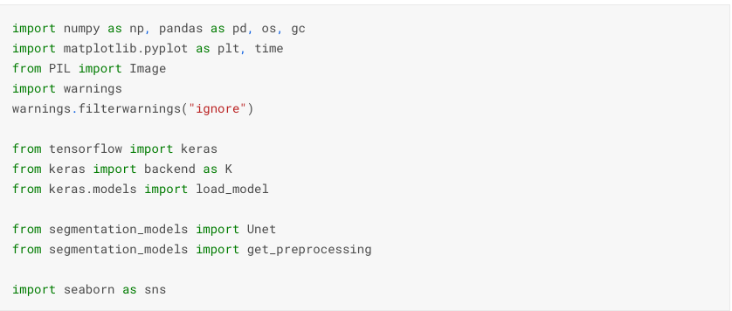

The most important component which we have not encountered before is the Unet module. Unet is a flexible architecture for segmentation: it combines an encoder (capturing the context in the image) and a decoder (for precise localization). Because it is built entirely of convolutional layers – without dense ones – it can accept image of any size. The segmentation-models package is a flexible implementation – with a major advantage that we can select from a wide variety of pretrained models for the encoder part.

As we know by now, a crucial step in the construction of a TensorFlow/Keras – based solution is setting up the data generator:

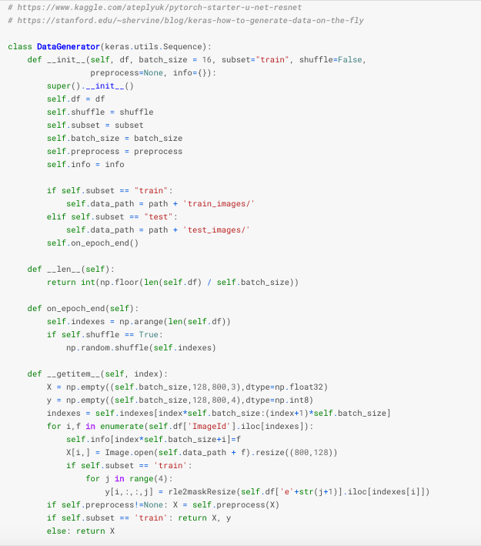

We can use the generator to visualize a few sample images with masks:

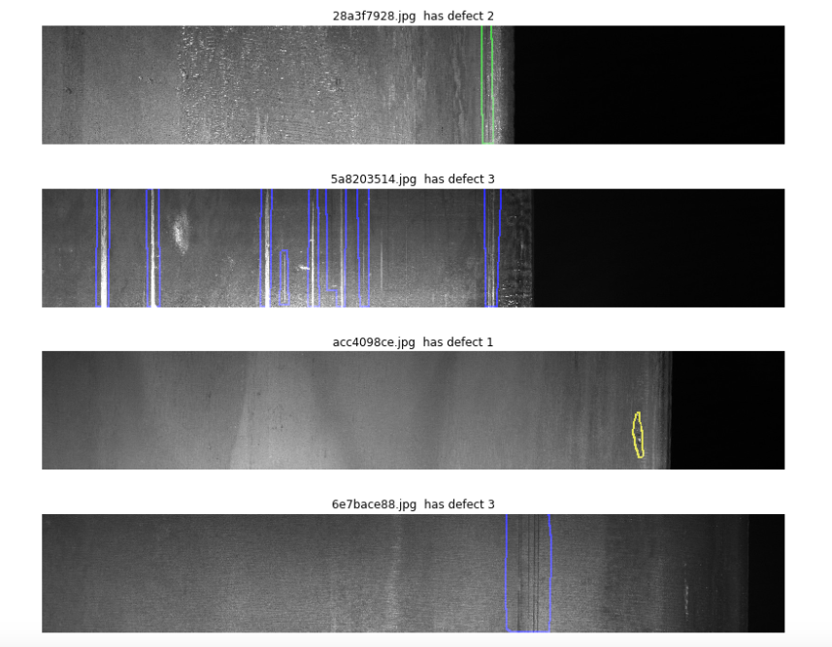

A popular metric choice in competitions related to segmentation is the Dice coefficient: double the overlap area between the target and our predicted region, divided by the total number of pixels in both.

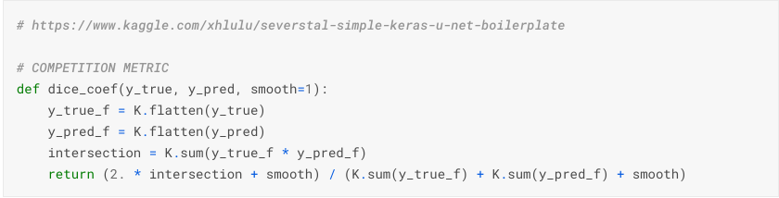

One more necessary step in a segmentation task is creating functions that convert run-length encoding <https://en.wikipedia.org/wiki/Run-length_encoding> - a format used here to describe the training data - into masks usable by the algorithm.

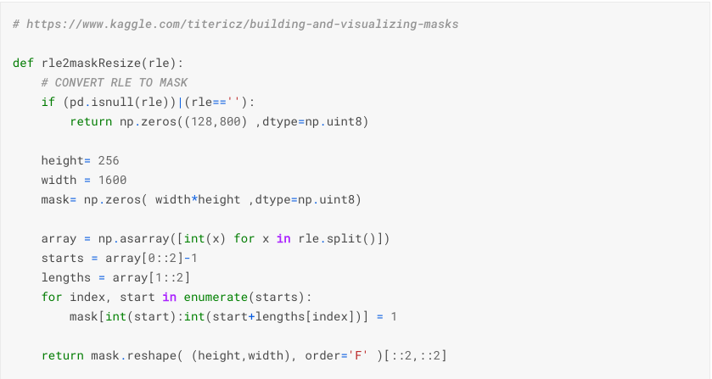

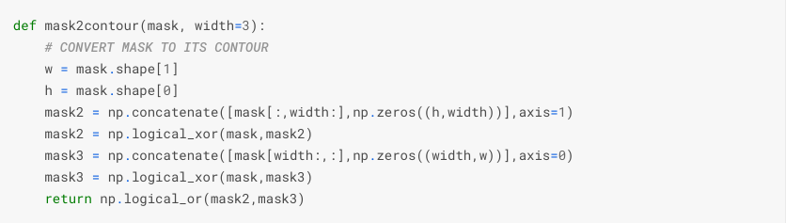

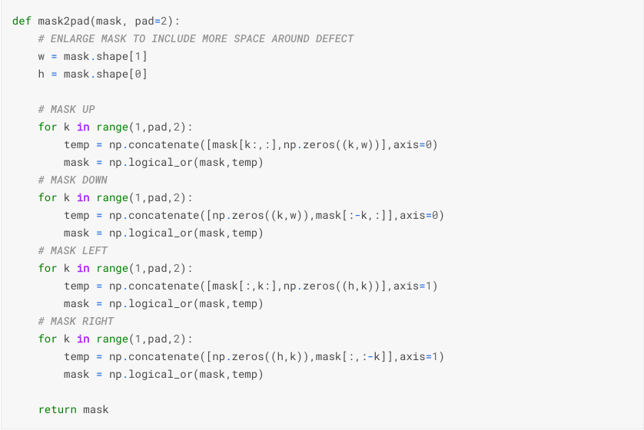

We recode the RLE encoding from the original data into the necessary format:

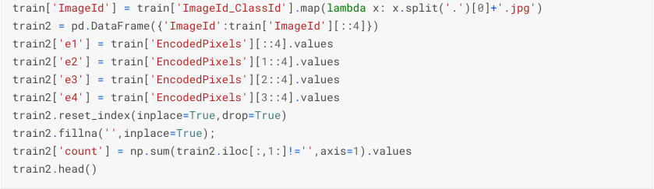

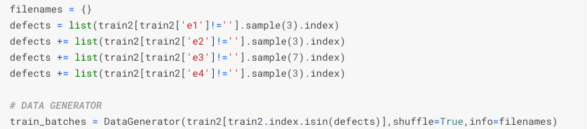

We can now train our U-net based model: the bottom is pretrained (the Resnet-34 component), we still need to tune the top of the model on our data.



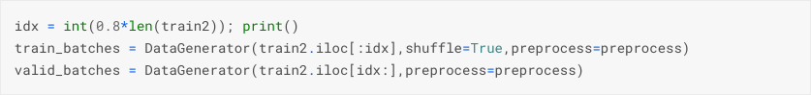



The above pipeline demonstrates how to setup a segmentation model and train it. We use a small number of epochs, but in order to achieve competitive results longer training is necessary. Such computations typically exceed the time limit of 9h, imposed in code competitions https://www.kaggle.com/docs/competitions. A typical workaround is to conduct a training first (in a Kaggle kernel, locally, in GCP or some other environment), and then upload the model weights to a second kernel (‘inference kernel’).

In this chapter we gave an overview of the most important topics related to computer vision from a Kaggle competition angle. We begin by discussing augmentations and then demonstrate three end-to-end pipelines for the two most popular tasks: image classification and semantic segmentation.